**Strategic Machines, Inc.**

**Agreement with Alex Scott**

**May 21, 2018**

**For professional services:**

**Microservice development and pilot of AWS platform**

The novel idea of Strategic Machines is that cognitive applications can be delivered in a short cycle at a lower economic price point by leveraging microservices. The term ‘cognitive’ has become synonymous with ‘artificial intelligence’, and as a result, many static or highly predictable tasks that can be handled through pure functions are being deployed to complex ai platforms. As a result, complexity and costs mount. Organizations are reluctant to adopt. Opportunity is lost.

Strategic Machines is dedicated to the delivery of winsome Brand interactions through chat. By meeting customers in any channel and delivering hybrid solutions through smart virtual agents, we help our clients gain a competitive edge in their respective markets. Microservices is at the heart of the architecture.

As additional context for this workorder, note the following diagram

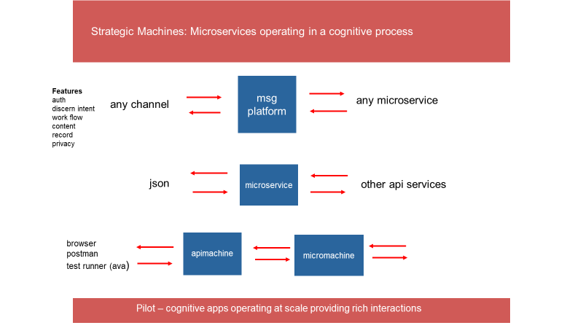

1. The ‘msg platform’ is designed to handle a text message from any channel (slack, sms, fb, telegram, viber etc.) The text message is authenticated, analyzed and passed to a microservice for processing as part of a uniform data object, along with a rich set of additional information that can be used by the microservice to compose responses.
2. The microservices receives a json data object, and processes that data object by initializing a constructor. The constructor (published as an npm package in the future) provides a set of functions for interrogating the value of properties on the data object and returns an array of replies to the messaging platform
3. The apimachine and micromachine are 2 simple servers, which ultimately needs to be integrated into a tool chain for building and delivering microservices at scale (cd/ci). The development of this tool chain is outside of the scope of this workorder – but documenting the process for another developer to follow is in scope.

This work order is more extensive than a typical workorder for a microservice since it involves a ‘pilot’ of the process a developer might follow in building, testing and deploying a service …as well as the delivery of a service against a set of specs.

The following requirements will be met as part of this work order

* Build a microservice and deploy to AWS Lamda
* The microservice will handle static requests for Mercy Church, helping to replace the functions that are already deployed for Mercy on the v0.5.0 platform**. (see appendix)**
* The single microservice will use a ‘switch case’ method and pivot off the classifier.topclass property on the data object. This property contains the ‘intent’ returned by the Watson classifier function. The Watson classifier is trained through a separate process and dataset (machine learning) to decipher a message received from the user.
* The ‘default case’ (to handle the case when the microservice does not have a case matching a Watson intent) should simply return the message ‘I did not understand your request. Please contact support’.
* For each intent that Watson is trained to recognize, the microservice is ‘configured’ or scripted to handle. You will note in the appendix that for any single intent, there are an array of responses and a link. This represents one ‘pattern’ for microservices that we will be designing against (the ‘static response’ pattern)
* The microservice selects a response from an array of responses randomly, returning the response and url (if one is provided)
* The microservice will us the constructor to interrogate the data object for values, and to provide a response array (**note:** I recognize the constructor is not entirely complete – and is poorly documented. ‘Challenges of a start-up’ but appreciate your feedback on new functions needed, existing functions that are broken, and ideas on how to improve. I will be upgrading the ‘constructor function’ periodically and will deliver through npm semver)
* Use apex.sh to deploy.
* The final ‘acceptance test’ for this AWS microservice will be executing the service successfully through the v0.8.0 version of the messaging platform (which I will construct when your microservice is ready to go)

------------------------

In addition

* Demonstrate disciplined and well-organized coding techniques for all modules delivered. Ensure that code is well structured and commented
* Tests for the microservice will be included as part of this deliverable using ava and supertest on apimachine
* Code will be delivered through pull requests on the ‘strategicmarket’ github site consistent with the codex. The PRs will include updates for apimachine and micromachine. In addition, a new repository will be delivered for the microservice, consistent with the package components of sm_banter example (readme, .github, license etc)
* Expected delivery date of final deliverable is targeted for no later than June 9, 2018.
* You agree that this is work for hire, work will be done in a quality manner, all deliverables are owned by Strategic Machines, Inc, and the work or concepts will be treated confidentially and not be disclosed to another party without express written permission of Strategic Machines
* This work order can be terminated by either party at anytime

**Payment:**

**$480.00**

upon delivery of this tested application. Any specific instructions for the operation or configuration of the app should be delivered as part of README file inside the directory for this app.

Your signature on the line below indicates your agreement to the scope and terms of this work order.

Keep 1 copy of this signed workorder for your records and return 1 copy to Strategic Machines

Agreed to:

Date:

**APPENDIX**

**Chart**

|  |  |  |
| --- | --- | --- |
| **intent** | **responses** | **attachurl** |
| music | He is Faithful! | http://bit.ly/2CWpxCb |
| music | Our God is forever faithful! | http://bit.ly/2CWpxCb |
| message | Here is the link to our sermon series | http://mercycharlotte.com/resources/all-series/ |
| banter | Hello! Welcome to Mercy Mobile |  |
| banter | Hi. We're delighted you're here. Check out our lastest sermon series. Or text worship for a song |  |
| banter | Thank you for texting us at Mercy Church. You can ask for a sermon, music, directions -- |  |
| help | Thank you for your text. Our messaging platform is only responding to a limited number of queries at this time. |  |
| help | Thank you for your text. Our messaging platform is only responding to a limited number of queries at this time. |  |
| help | Thank you for your text. Our messaging platform is only responding to a limited number of queries at this time. |  |
| support | Thank you for your text. Our messaging platform is only responding to a limited number of queries at this time. |  |
| support | Thank you for your text. Our messaging platform is only responding to a limited number of queries at this time. |  |
| prayer | Thank you for your text. Our messaging platform is only responding to a limited number of queries at this time. |  |
| prayer | Thank you for your text. Our messaging platform is only responding to a limited number of queries at this time. |  |
| times | Our worship services are held at 9am and 11 am on Sunday, at the Levine Center in Matthews | http://mercycharlotte.com/about/worshipservices/ |
| events | Thank you for your text. Our messaging platform is only responding to a limited number of queries at this time. |  |
| events | Thank you for your text. Our messaging platform is only responding to a limited number of queries at this time. |  |
| cg | Thank you for your text. Our messaging platform is only responding to a limited number of queries at this time. |  |
| cg | Thank you for your text. Our messaging platform is only responding to a limited number of queries at this time. |  |
| weather | Thank you for your text. Our messaging platform is only responding to a limited number of queries at this time. |  |
| location | We hope to see you at Mercy Church. Check out the link for our location | http://bit.ly/2wAUDeR |
| location | Mercy Church meets in Matthews. Here is a link to find us! | http://bit.ly/2wAUDeR |
| location | We meet at the Levine Center in Matthews. Here is a google map for your reference | http://bit.ly/2wAUDeR |
| music | Worship our Lord! | http://bit.ly/2CWpxCb |
| mission | Thank you for your interest in serving. Please reference the attached link for short term mission trips | <https://bit.ly/2qLtvd4> |
| beliefs | Please contact a member of our pastoral team if you have any additional questions about Mercy Church or our beliefs | http://mercycharlotte.com/about/beliefs/ |
| children | Thank you for your text. Our messaging platform is only responding to a limited number of queries at this time. |  |
| students | Thank you for your text. Our messaging platform is only responding to a limited number of queries at this time. |  |
| college | Thank you for your text. Our messaging platform is only responding to a limited number of queries at this time. |  |
| giving | Thank you for your text. Our messaging platform is only responding to a limited number of queries at this time. |  |
| registerstartingpoint | Thank you for your interest in Starting Point. We look forward to seeing you there! Please RSVP by clicking on the attached link! | http://bit.ly/2B5hoKn |
| music | Enjoy! | http://bit.ly/2CWpxCb |
| whatisstartingpoint | Starting Point is your opportunity to learn more about the Mercy Community! | http://bit.ly/2CyOPad |
| whenisstartingpoint | Starting Point is held nearly every month. We hope to see you at the next one! |  |
| whereisstartingpoint | Starting Point will be held at the Levine Center | http://bit.ly/2wAUDeR |
| childcarestartingpoint | Yes. Childcare is provided at starting point but you will need to register when open |  |
| worship | Here is the link to the Mercy Playlist on Spotify | http://spoti.fi/2FJ14SQ |
| membership | Join us for Starting Point Weekend to learn more getting involved with the Mercy Community! | http://bit.ly/2CyOPad |
| member | Great! Do you need child care for that evening? |  |
| decline | We're sorry you cannot join us for member night! |  |
| memberchild | Tap the link to register for child care on member night. | http://bit.ly/2B5M79Y |
| member | Great! Do you need child care for the evening |  |
| member | Great! Do you need child care for that evening? |  |
| close | Thanks! |  |
| easter | Easter begins our new series: "Getting Started". Check out the link! | http://mercycharlotte.com/easter/ |
| easter | We so look forward to seeing you on Easter. Be sure to invite a friend! | http://mercycharlotte.com/easter/ |
| easter | See you on Easter Sunday! Our new series will be exciting! | http://mercycharlotte.com/easter/ |
| easter | Let's worship our risen Lord on Easter! Check out the link for our new series! | http://mercycharlotte.com/easter/ |
| easter | Easter will be a glorious day of celebration! Bring a friend! | http://mercycharlotte.com/easter/ |
| music2 | He's alive! Enjoy the newest single from Mercy Worship. | https://bit.ly/2GKg8TH |
| serveweek | Enjoy serving our City! Please tap the link to sign up! | https://bit.ly/2FFCz7V |